CSA-0717

Lab Experiments 11-15

1. Designing two different networks with Static Routing techniques using Packet Tracer.

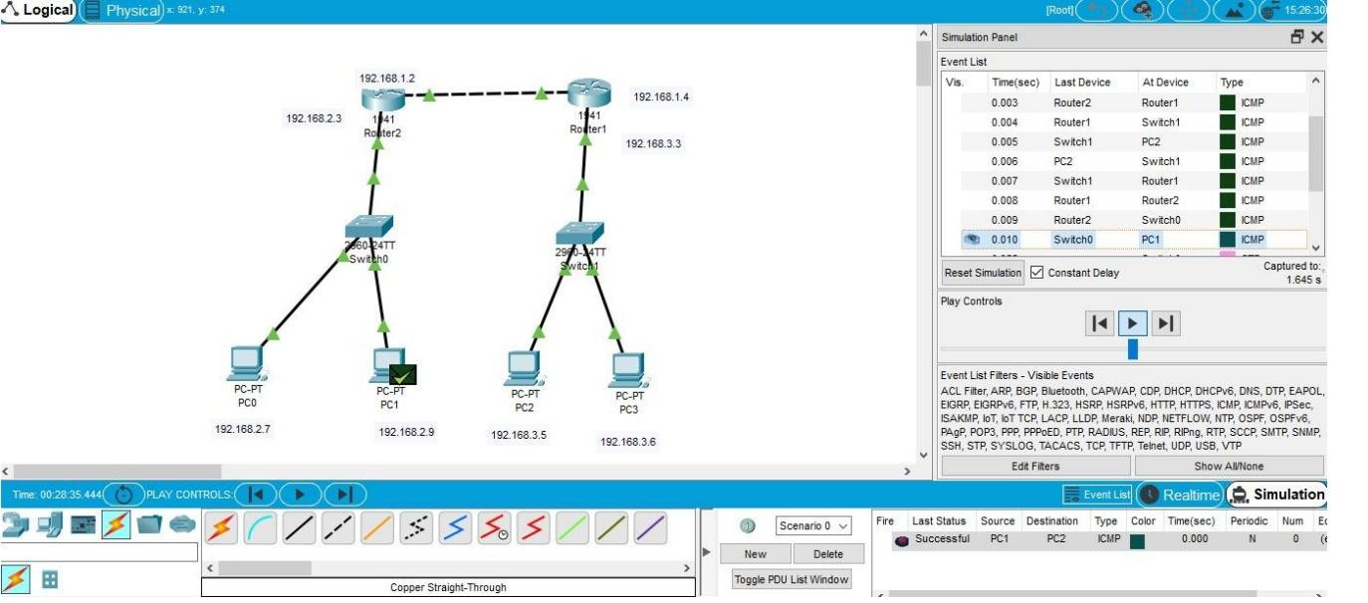

1. Designing two different networks with Dynamic Routing techniques (RIP & OSPF) using Packet Tracer

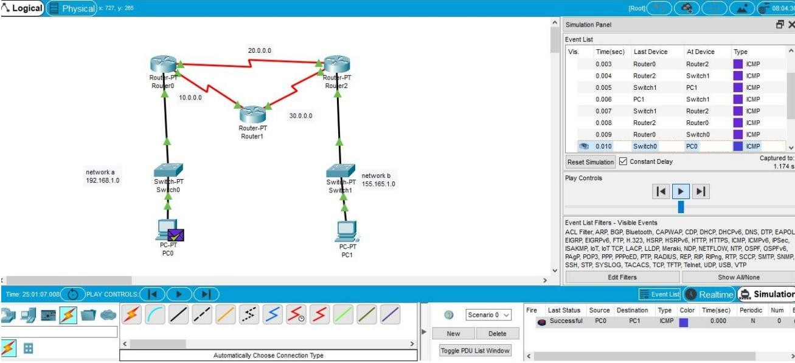

1. Design the Functionalities and Exploration of TCP using Packet Tracer

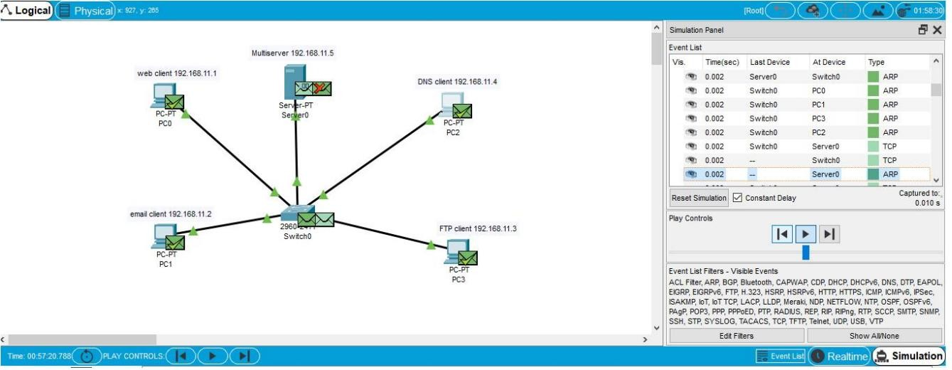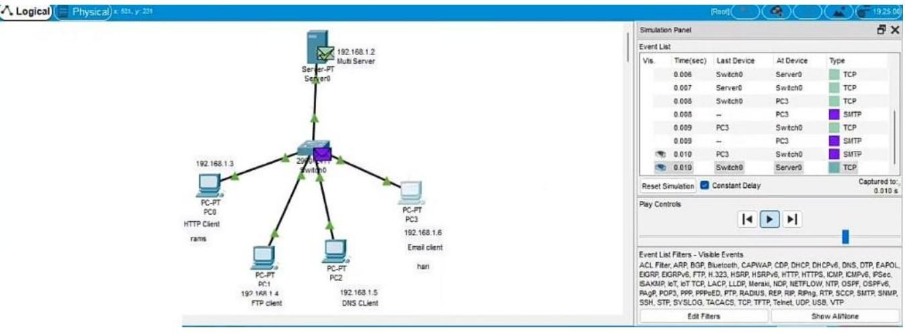

1. Design the Functionalities and Exploration of UDP using Packet Tracer.

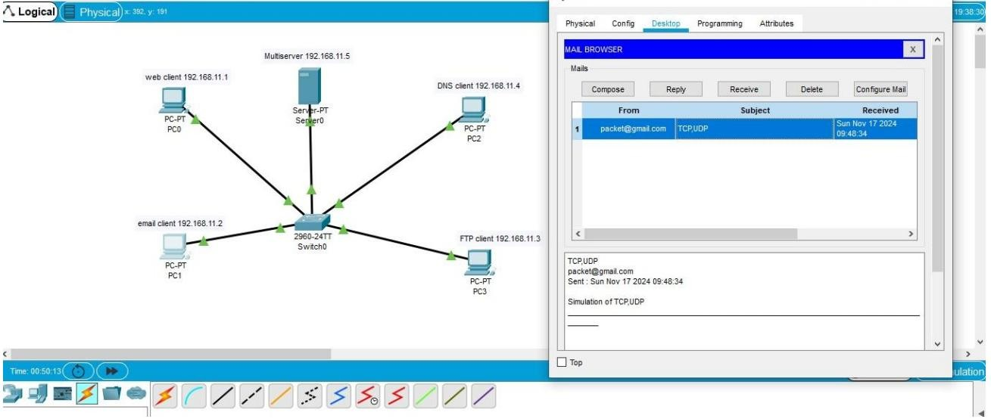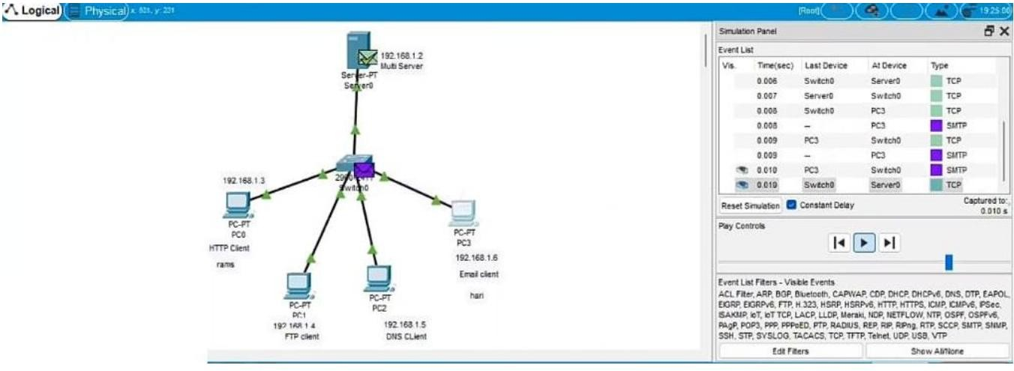

1. Design the network model for Subnetting – Class C Addressing using Packet Tracer.

